Name: Nafinur Leo

Id: 20-42195-1

Course: Computer Organization And Architecture

Section: C

Date: 15-02-2022

Home Task

Task1:

Code:

.MODEL SMALL

ORG 100H

.STACK 100H

.DATA

CR EQU '0DH'

LF EQU '0AH'

MSG DB 'HELLO WORLD $'

.CODE

MAIN PROC

MOV AX,@DATA

MOV DS,AX

MOV CX,5

PRINT_:

LEA DX,MSG

MOV AH,9

INT 21H

MOV AH, 2

MOV DL, 0DH

INT 21H

MOV DL, 0AH

INT 21H

DEC CX

JNZ PRINT_

MOV AH,4CH

INT 21H

MAIN ENDP

END MAIN

RET

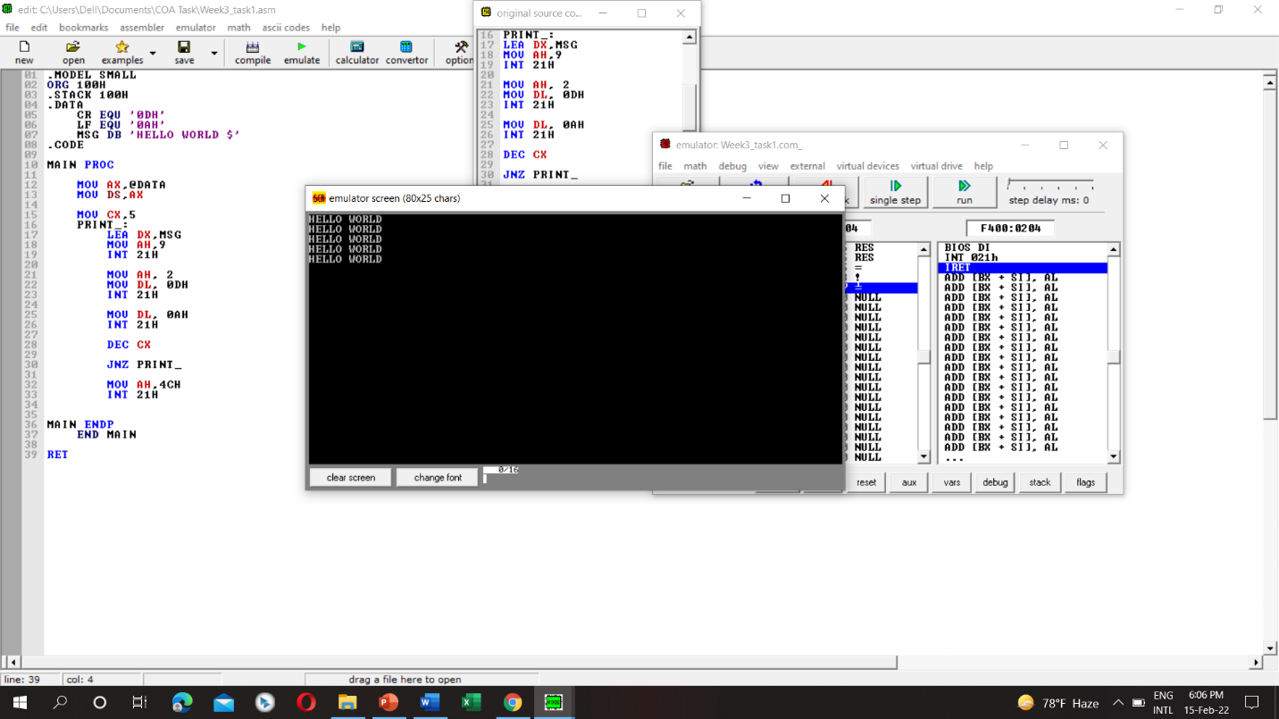

Task2:

Code:

.MODEL SMALL

ORG 100H

.STACK 100H

.DATA

MSG1 DB 10,13,'INPUT:$'

MSG2 DB 10,13,'INPUT IS EQUAL TO 5 $'

MSG3 DB 10,13,'INPUT IS GREATER THAN 5 $'

MSG4 DB 10,13,'INPUT IS LESS THAN 5 $'

.CODE

MAIN PROC

MOV AX, @DATA

MOV DS,AX

MOV AH,9

LEA DX,MSG1

INT 21H

MOV AH,1

INT 21H

MOV BL,AL

CMP BL,'5'

JE @EQUAL

JG @GREATER

JL @LESS

@EQUAL:

MOV AH,9

LEA DX,MSG2

INT 21H

JMP END

@GREATER:

MOV AH,9

LEA DX,MSG3

INT 21H

JMP END

@LESS:

MOV AH,9

LEA DX,MSG4

INT 21H

JMP END

END:

MOV AH,4CH

INT 21H

MAIN ENDP

END MAIN

RET

